**Uploading Data**

LegCRM provides a robust upload facility. Note that voter data is pre-loaded and updated periodically, so you do not need to upload voter or resident lists. However, you may want to use the upload facility in the following contexts (for example):

* Importing history from an existing system
* Recording signers of a petition
* Recording attendees of an event

To upload data you must have it saved as some form of delimited file, the most common being “csv”, but you an also use a tab delimited txt file. Most spreadsheet programs allow you to export data in csv format.

To get started, click the upload icon.

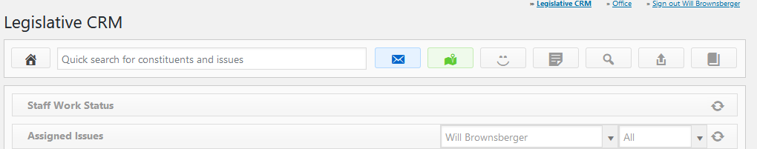

The upload process will guide you through the steps of uploading data:

* Parsing the file to make sure it is properly formatted
* Mapping the columns of the file to database fields
* Validating data
* Defining match rules to avoid duplicate creation
* Setting default activities to record for each added constituent (for example, Petition on January 12, 2021 on Impeachment).
* Finishing the uploaded

You can use upload process to upload both activities and constituents either simultaneously or separately. It can also create new issues as it goes. These capabilities support conversion of data from other systems.